

Visual approaches to cultural heritage

CERL Seminar at ETH Library, 14 March 2018
Venue: ETH Zurich, LEE Building (Leonhardstrasse 21), Room E 101.

The ‘icon turn’ has drawn the attention of scholars to visual material and its interpretation. This approach offers
a wide range of ways for it to be combined with text-based scholarship, thus opening up new perspectives. Image-based search tools to sources and the visual presentation of research results have, however, not emerged equally as fast. ETH Library, the Swiss centre for technical and natural scientific information, has therefore seized the opportunity to organise the CERL Spring Seminar 2018 with a view to discussing innovative forms of access to and the visualisation of research results.

Registration: please complete the registration form and send to secretariat@cerl.org before 6 March 2018.

08.30 | Registration and Coffee
 | Welcome and Opening Remarks
09.00-09.15 | Andreas Kirstein, Deputy Director, ETH Library  Kristian Jensen, Chairman, CERL
 | Introduction
09.15-09.30 | Stefan Wiederkehr, Head of Collections and Archives, ETH Library
 | Panel 1: Access to sources
09.30-10.15 | Meda Diana Hotea (ETH Library, Zurich): ETH Library’s visual and map-based access to selected digital information resources
10.15-11.00 | William O. Duba/Maria Widmer (University of Fribourg): e-codices and Fragmentarium. Building for and building upon the interoperability paradigm
11.00-11.30 | Coffee
11.30-12.15 | Claudia Fabian (Bayerische Staatsbibliothek, Munich): Image-based Similarity Search at Bayerische Staatsbibliothek
12.15-13.00 | Hans Brandhorst/Etienne Posthumus (Brill, Leiden): Arkyves – a serendipity engine
13.00-14.30 | Lunch
 | Panel 2: Visualisation of research results
14.30-15.15 | Matthias Bixler (University of Zurich): Connecting the Dots. The Use of Visualisations in Historical Network Research
15.15-16.00 | Matilde Malaspina/Cristina Dondi (15cBOOKTRADE, Oxford and CERL): Tracking and visualising the circulation of books and of illustrations: 15cV and 15cILLUSTRATION
16.00-16.30 | Coffee
16.30-17.15 | Frédéric Kaplan (EPF Lausanne): Why Europe should build a Time Machine
17.15-18.00 | Anna Neovesky (Academy of Sciences and Literature, Mainz): Visual Approaches to the Presentation and Analysis of Text Corpora: Case Studies on Digital Collections of Medieval and Early Modern Sources
19.30 | Dinner (for those who have registered their attendance)
Directions

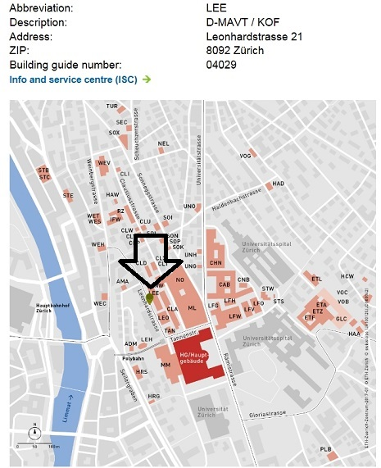

Travelling by public transport from Zurich Airport

By tram
- From the “Zurich Airport” tram stop
- Tram no. 10 (towards Bahnhofplatz/HB) as far as the “Haldenegg” stop. The tram runs every 7 to 15 minutes between 6 o’clock in the morning and 11 o’clock at night.
- Journey time: 30 minutes

By rail
- If you wish to travel from the airport to the city centre (Central Station), you are recommended to use the S-Bahn or mainline services. The trains depart from the “Zurich Airport” station.
- Journey time: approx. 10 minutes

You will require a ticket valid for 3 zones.
If you are spending the whole day in Zurich, it is worth buying a day pass (valid for 24 hours). A 24h ticket costs only twice as much as a regular one-way ticket.

Travelling by public transport from Zurich Central Station

From the “Bahnhofstrasse/HB” stop: Tram no. 6 (towards the Zoo) as far as the “ETH/Universitätsspital” stop. Journey time: approx. 6 minutes

From the “Bahnhofplatz/HB” stop: Tram no. 10 (towards the Airport or Oerlikon station) as far as the “Haldenegg” stop. Journey time: approx. 8 minutes
You will require a ticket that is valid for zone 110 (city of Zurich).

Further Information:
Campus: https://www.ethz.ch/en/campus/locations/zurich-region/HG.html
Tourist Information: https://www.zuerich.com/en

