Annual General Meeting of the Consortium of European Research Libraries, National Library of Russia, St Petersburg, 14 November 2003

Executive Manager’s Report

File loads in 2002-2003

At the time of the Full Members’ meeting in 2002 nineteen files were combined in the Hand Press Book database with a total of 1,287,469 records. This year three new files – the VD16 Supplement maintained by the Bayerische Staatsbibliothek, München; XML records from the National Library of Hungary; and records from the libraries of Yale University – were dispatched to RLG. The University of Oxford have submitted a file update of over 83,000 records. At the time of writing this report the VD16 Supplement file is part of the HPB database, and the files from Oxford and London are expected to be loaded by the time of the AGM meeting. Once all files have been added to the Hand Press Book database it will total over 1,695,000 records.

 |  | Number of records | Cumulative total | ESTC
1997
1 | BSB Munchen | 526,920
2 | KB Stockholm – SB17 | 48,950
3 | NUL Zagreb | 2,346
4 | ICCU – SBN(A) | 45,303
5 | BnF Paris | 27,935
6 | NL Scotland | 14,287
 | Total | 665,741 | 665,741
1998
7 | NUL Ljubljana | 18,837
8 | KB The Hague – STCN | 56,921
9 | BL - K17 | 24,183
 | Total | 99,941 | 765,682
1999
10 | BL – ISTC | 28,892
11 | BNE | 11,054
 | Update: ICCU/SBN(A) | 15,472
 | Total | 55,418 | 821,100
2000
12 | Oxford – EPB project | 44,555
13 | KB Stockholm – SB16 | 6,021
 | Total | 50,576 | 871,676 | 461,562
2001
14 | NLR | 8,321
15 | ULL | 38,613
16 | CLC | 25,718
 | Updates: ICCU/SBN(A) | 79,571
 | KB The Hague – STCN | new: c. 44,000
 | Total | 197,136 | 1,068,812 | 464,087
2002
17 | Warsaw UL | 1,866
18 | SUB Göttingen | 157,371
19 | Wellcome Institute | 51,671
 | Updates: NLR | new: c. 2,200
 | BNE | new: c. 3,500
 | Total | 218,657 | 1,287,469 | 466,414
2003
20 | VD16 Supplement (BSB) | 28,469
21 | NL Hungary | c. 13,000
22 | UL Yale | 275,232
 | Updates: Oxford Libraries | c. 83,790
 | Univ. of London Libs | c. 7,200
 | Total | c. 407,700 | c. 1,695,150 | 468,361

Total HPB and ESTC combined: c. 2,163,500
Future file loads
In 2003-2004 CERL aims to add more than 200,000 records to the HPB database. A large number of files is at various stages of preparation.

The file loading chain is complex and can be slow. Pressures at local level can lead to delays, and can make maintaining an evenly spread and regular file delivery to RLG very difficult. CERL continues to work on a large number of files simultaneously, with the aim of ensuring regularity in file delivery to RLG, thus speeding up the file loading process.

CERL would like to thank Tony Curwen very warmly for his work on analysing a number of the files listed above, as well as all his aid in preparing the files below for loading in the HPB database. The following files are in preparation:

DCG / TC file analysis sent to file provider
 | BL– Scandinavian records | c. 12,854 | UKMARC
 | BN Naples – Brancacciana | c. 100,000 | UNIMARC
 | BN Portugal – Spanish and Portuguese material + Elsevier collection | c. 3,900 | UNIMARC
 | Canterbury – Mendham collection | c. 5,000 | UKMARC
 | NL Czech Republic | c. 200-500 | UNIMARC
 | NL Lithuania | c. 2,700 | UNIMARC
 | Regione Toscana – L.A.I.T. | c. 10,000 | UNIMARC
Files offered / to be sent to CERL
 | KB Copenhagen | c. 42,000 | UNIMARC | Test file expected Nov. 2003
 | KB Stockholm, legal materials | c. 12,500 | MARC21
 | KBR Brussels | c. 12,000
 | Mazarine, Paris | ?
 | NL Wales | c. 3,500 | MARC21 | November 2003
 | STC-V | c. 3,500 | MARC21/XML
 | St-Geneviève, Paris | c. 120,000 | UNIMARC
 | UL Helsinki – Fennica | c. 25,000 | UNIMARC
 | UL Salamanca | 4,.478 | MARC21
DCG have begun preparations for conversion to UNIMARC
 | 4 Polish libraries’  German holdings | 30,520 |  | Needs to be conv. to UNIMARC
 | BSB-VD17 | c. 25,000 | UNIMARC | Needs to be conv. from MAB
 | Zeitschriften Datenbank | c. 11,500 |  | Needs to be conv. to UNIMARC
Updates
 | ICCU – SBN(A) | c. 52,000 | UNIMARC | January 2004
 | NL Croatia | c. 6,500 | UNIMARC | Early 2004
 | NLR | c. 4,000 | UNIMARC
 | NLS | ? | MARC21 | 2004
 | SUB Göttingen | ? | UNIMARC
 | UL Warsaw | c. 1,500 | UNIMARC

CERL Thesaurus file and Assisted Searching

The CERL Thesaurus is designed as an independent database, and contains variant forms of place names, imprint names and personal names. Its records are held in a format that is based on UNIMARC authorities and is freely accessible through the CERL website: http://www.cerl.org/Thesaurus/thesaurus.htm.

The CERL Thesaurus is composed mainly of authority files provided by CERL members. This year the authority file of the Short-Title Catalogue Netherlands for printers and personal names, The Hague has been re-loaded; the authority file of the English Short-Title Catalogue has been added. Work is underway to load the records of the Personennamendatei (PND) the German national authority file. The records derived from STCN, Zagreb, ESTC, BNF imprimeurs and PND will have to be merged, if they relate to one and the same item. DCG will add relevant data in these files to the CERL Thesaurus on the basis of algorithmic matching. At present there is only little overlap so that users of the CT are not really aware of redundant information, but controlled merging will be become an issue, and CERL is investigating a suitable editing programme.

Other files that are to be included are:
- CLC: Authority records for imprint names
- SUB Göttingen: Authority records for imprint names and personal names
- CLC: Authority records for personal names
- Getty TGN: Records for imprint places
- ICCU: Edit16 imprint names

Editing
A programme of intellectual, manual editing of the CT’s place names has nearly been completed by Ms Ute Klier, who is based at the Bayerische Staatsbibliothek. CERL members are asked to examine the place names for their country and inform the Executive Manager of corrections they wish to see implemented.

Dr Sarah Cusk, London, has undertaken to provide DCG with a list of sources cited in abbreviated form in the ESTC, so that full details of the sources can be provided in the CERL Thesaurus.

Notepad
DCG have developed a prototype for a ‘notepad’ for the CERL Thesaurus, which is currently under examination by the members of the ATG. the CT window. In the test installation the messages sent this way are received by DCG. However, when the system goes ‘life’ messages will be sent to the CERL secretariat, who can distribute copies according to subject (which can be selected by the user). If users | 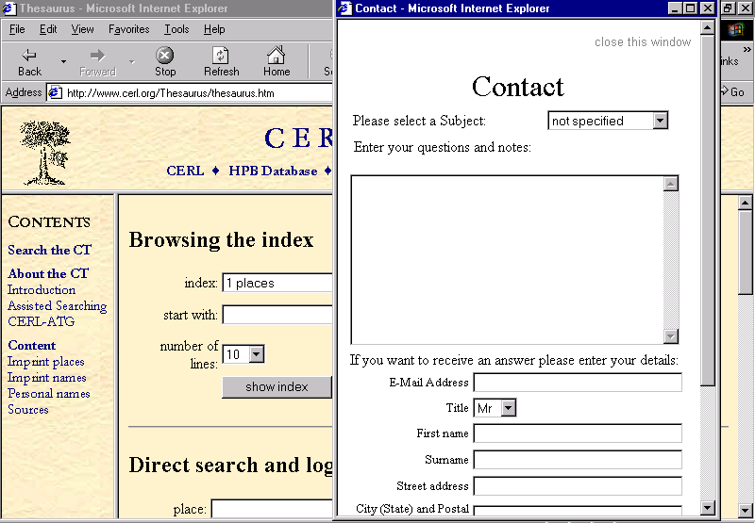
wish to relate their message to a specific record they can copy part of it or the entire record into the notepad and add their own remarks. As a further development, it may be possible to install a mechanism which sends a message with a specific subject to a specified address (e.g. a message about imprint names would go directly to the editing team at Munich); a copy of the message will be sent to CERL.

Assisted Searching on the HPB database
After Assisted Searching on Imprint Places and Imprint Words, RLG and DCG are now preparing the implementation of Assisted Searching on Personal Names. Once a search on an Personal Names has been executed the button Variant Personal Names will appear. When this button is clicked, a search is executed on the CERL Thesaurus and the resulting variant forms of personal names can then be used as search terms on the HPB.

Falcon software  DCG have further developed the Falcon file analysis software that has proven to be a tool that is gratefully used by Tony Curwen and certain file providers in the preparation of HPB and CT file loads (BN Lisbon, NL Wales). Tony Curwen and Micheal Rzehak are in the process of refining the Falcon manual. | 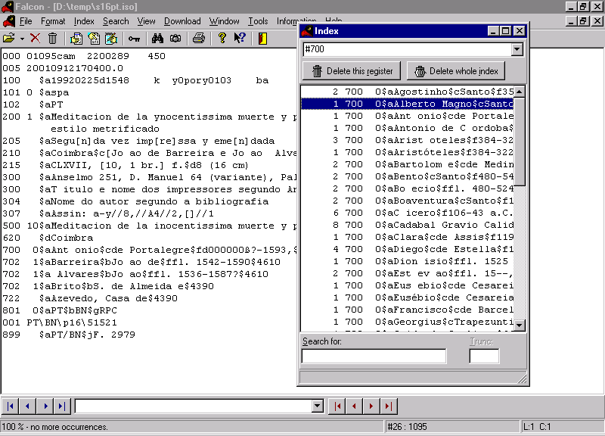

Executive Committee

The Executive Committee met three times this year: 15 March in London, 7 June in Paris and 12 November in St Petersburg. In each meeting it heard reports from the Secretary, the Treasurer, the Executive Manager and the Chair of the ATG, and discussed membership and financial issues, current and future file loads, and particularly future database developments, such as the MSS project. In addition the Executive Committee discussed the costs of HPB file loads, Membership issues, the 2004-2006 RLG contract extension, promotion of CERL, and the work of the Services Working Group.

Data Conversion Group, Göttingen

This year, DCG analysed the VD16 Supplement file, a file containing Polish microform records and files from the Regione Toscana (LAIT records) and National Library of Lithuania. Additionally, much DCG effort went into to the further development of the CERL Thesaurus file, as shown above. CERL would like to thank Micheal Rzehak, Julia Haasse, Jürgen Braun, and Werner Schwartz of the Data Conversion Group for all their hard work.

Research Libraries Group, Mountain View, CA

During 2001-2002 Mr Wes Taoka was CERL’s interim contact person with RLG, after the departure of Dr Curtis Lavery. As announced in the December issue of the CERL Newsletter, Dr Lavery’s position has now been filled by Ms Pamela Wilkes. Ms Wilkes attended the CERL meetings in London and St Petersburg.

Joe Altimus worked on the file loads of BSB’s VD16 Supplement and the XML records of the National Library of Hungary, Dana Jemison on the Oxford and Kathy Farrell on the ULL file loads. The latter will also prepare the Yale University Library records for inclusion in the HPB. CERL would like to thank all RLG colleagues very much for the pleasant working relationships.

Promotion of CERL and the HPB

CERL Newsletter
In December 2002 and June 2003 CERL members received the 6th and 7th issues of the Newsletter with information on HPB file updates and the CERL Thesaurus, a report on the 2002 AGM, the Manuscripts Working Group, new CERL members, and other organisational news. The 6th issue reported also reported on ULL Manuscripts Studies Portal, a follow up on the report on a conference on security management of historical collections, and advance information on the 2003 AGM. The 7th issue of the Newsletter contained an article on provenance data, FRANAR and RLG’s new Technical Services Infrastructure. If members wish to contribute to the CERL Newsletter (next issue to be published in December 2003), please contact the CERL Executive Manager.

Use of the databases

By CERL Members
More searches were executed on the HPB database (up by 46%) and the ESTC file (45%) – the number of searches executed on the BIB is slightly down. This year 56 CERL Members (excluding Cluster libraries) used the various databases CERL offers – this is up from 53 members last year. The HPB was used by 53 institutions, the ESTC by 38 institutions, RLG’s Union Catalogue by 32 and the other files by 15 CERL members.

 | 97-98 | 98-99 | 99-00 | 00-01 | 01-02 | 02-03
HPB | 3,141 | 8,019 | 20,187 | 22,579 | 33,215 | 48,558
ESTC | 5,606 | 13,461 | 22,651 | 29,523 | 28,143 | 40,719
BIB | 2,697 | 5,100 | 18,619 | 10,775 | 27,237 | 23,635
Other | 597 | 307 | 475 | 152 | 222 | 340
Pass/Put | 1,489 | 1,589 | 997 | 1,099 | 350 | 579

The fact that more members used the HPB database does not wholly account for the increase in the number of searches. In 2000-2001 37 Members executed 22,579 searches or 610.2 searches per member; in 2001-2002 the average was 585.75 searches per member (51 institutions), and this year it is an average of 703.43 searches per institution.

Some of these extra searches will have been executed by readers in members’ reading rooms. We are very pleased to see that as many as 22 CERL members are offering free public access to the Hand Press Book database on in excess of 670 computer terminals.

As last year, the table below shows that with regard to the ESTC and the BIB file, a relatively small number of institutions are responsible for almost all searches. The number of institutions executing 200 or more searches on the HPB is much higher (27) than the ESTC and BIB users.

 | Number of institutions executing over 200 searches
HPB | 27/53
ESTC | 13/38
BIB | 8/32

CERL has made no charges for the use of these files, except for the use of the so-called BIB files. Members were given 200 free searches and after that were charged $0.82 per search for the use of RLG’s Union Catalogue: Bibliographic Files and Authority Files, the CURL and DBI databases, and the records of the National Library of Australia.

By Cluster Libraries
CERL now has eleven groups of ‘cluster’ libraries that have access to the HPB and the ESTC files. The total number of searches on HPB was 11,276: only four Cluster groups searched the ESTC file.

 | No. of HPB searches | No. of months
- BN Portugal Cluster | 4,244 | 12
- ICCU Cluster | 3,298 | 12
- BNE Madrid Cluster | 1,972 | 8
- Soprintendenza Cluster | 929 | 12
- NLR St Petersburg Cluster | 287 | 4
- SUB Göttingen Cluster | 182 | 12
- BSB München Cluster | 163 | 12
- Regione Toscana Cluster | 121 | 8
- NUL Zagreb Cluster | 62 | 3
- CAB Padua Cluster | 16 | 7
- NLS Edinburgh Cluster | 2 | 4
Total | 11,276

By RLG Members
From September 1998 RLG has made the HPB available to its members. Details on the institutions using the HPB through RLG may be found in the RLG report.

Marian Lefferts
30 October 2002

