UNIQUE AND UNIVERSAL: CHALLENGES FOR THE MANUSCRIPT LIBRARIAN
The Library of Trinity College Dublin, 25-27 May 2016
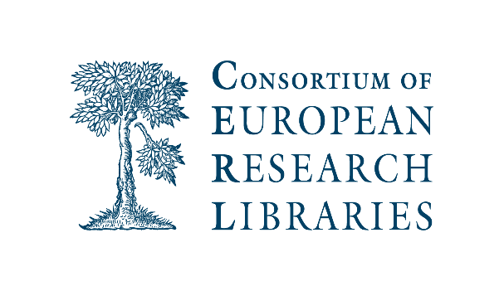
EUROPEAN MANUSCRIPT LIBRARIANS EXPERT GROUP, 7th CONFERENCE
The primary aims of the Group are to act as a forum for curatorial concerns, and to enhance understanding and practical cooperation among curators across Europe.
The conference will focus on these themes:
Commemorations and Anniversaries; Post-digital Issues and Concerns; Materiality.
Wednesday 25 May
1315: Registration
1400: Helen Shenton (Librarian and College Archivist, Trinity College Dublin), Welcome.
Session 1: chair, Bernard Meehan
1410: Commemoration
- Estelle Gittins (Library TCD), ‘Ireland’s Decade of Commemoration: Marking 1916 in the Library of Trinity College Dublin’
1440-1600: Post-digital Issues and Concerns
- Jennifer Edmond (TCD), ‘CENDARI: what next?’
- Jane Ohlmeyer (TCD), ‘The 1641 Depositions: what now?’
1600-1630: tea
Session 2: chair, Jutta Weber
1630-1730: Materiality
- Bernard Meehan (Library TCD), ‘The Faddan More Psalter’
- Susie Bioletti (Library TCD), ‘Early Results from the “Early Irish Manuscripts” Project’
1800: Reception in Old Library with Book of Kells and exhibition of treasures
Thursday 26 May
Session 3: chair, Felicity O’Mahony
0930-1100: Materiality
- Ad Leerintveld (Koninklijke Bibliotheek, Netherlands), ‘Authenticating the coat of arms in a Gruuthuse manuscript’
- Birgit Vinther Hansen (Kongelige Bibliotek, Copenhagen), ‘Exhibition and fading of manuscripts: microfadometry and a lighting policy to increase exposure and reduce risk’
- Nicholas Pickwoad (University of the Arts, London), ‘Ligatus: the importance of bindings and their description’
1100-1130: coffee
Session 4: chair, Jane Maxwell
1130-1300: Commemoration
- Claire Breay (British Library), ‘Commemorating the 800th anniversary of Magna Carta in 2015’
- Rebecca Boxler Ødegaard and Bente Granrud (National Library of Norway), ‘A decade of writer's commemorations - and what we have learned’
- Matthew Shaw (Institute of Historical Research, London), ‘Europeana 1914-1918 and creating a digital collective memory’
1300-1400: lunch
Session 5: chair, Ellen O’Flaherty
1400-1530: Post- digital Issues and Concerns
- Matthew McGrattan (Bodleian Library Oxford), ‘International Image Interoperability Framework and Bodley’
- Allen Packwood (Churchill College, Cambridge), ‘The Churchill Papers: a modern historical epic’
- Gerhard Müller (Staatsbibliothek zu Berlin): ‘Understanding Archival Metadata and Shaping Perspectives on the Benefits of Standards beyond the Simple Search’
1530-1600: tea
1600-1645: discussion, led by Jutta Weber (Staatsbibliothek zu Berlin)
1700-1900: Reception at Royal Irish Academy and viewing of early medieval Irish manuscripts. Welcome by Siobhán Fitzpatrick, Librarian.
1930: Conference Dinner: Dunne and Crescenzi, South Frederick Street, Dublin 2.

Friday 27 May
Private visits to Marsh’s Library and Chester Beatty Library.
0850: Meet at Trinity College front gate
0915-1015: Marsh’s Library:
Guided tour by Dr Jason McElligott, Keeper of Marsh's Library, of the exhibition dealing with the 1916 Rising, as well as the opportunity to view rare survivals of medieval fragments found inside the bindings of early-modern books.
1045-1145: Chester Beatty Library: limited to two groups of 20.
1045: Meet at main reception of Chester Beatty Library
Group 1: Tour of ‘Lapis & Gold: The Story of the Ruzbihan Qur’an’
Temporary Gallery with Dr Elaine Wright, Curator of Islamic Collections
Group 2: Highlights from the East Asian Collections
Reading Room with Dr Mary Redfern, Curator of the East Asian Collections
1115: Meet at main reception. Reverse tours.
1145: End.
Opportunity to explore the Chester Beatty Library's two permanent galleries (self-guided).

http://www.tcd.ie/Library/1916/
http://www.cendari.eu/
http://www.1641.tcd.ie/
http://www.museum.ie/Archaeology/Exhibitions/Current-Exhibitions/The-Treasury/Gallery-1-Iron-Age-to-12th-Century/Gallery-2-The-Faddan-More-Psalter-(1)/Context-and-Significance
http://www.tcd.ie/Library/early-irish-mss/
http://www.ligatus.org.uk/
http://www.europeana1914-1918.eu/
http://iiif.io/
https://www.chu.cam.ac.uk/archives/collections/churchill-papers/
http://www.dunneandcrescenzi.com/dunne-and-crescenzi/dunne-and-crescenzi-south-frederick-street-south-frederick-street.249.html
http://www.marshlibrary.ie/
http://cbl.ie/

