Dear Colleagues

CERL Annual General Meeting, Saturday 10 November 2007
We are writing to give notice that the Consortium’s 2007 Annual General Meeting will be held on Saturday 10 November 2007 in the University Library, Uppsala (http://www.ub.uu.se/) at 9.30 a.m. A full agenda and papers will be provided at a later date for downloading from the CERL web site.

CERL Annual Seminar, Friday 9 November 2007
We hope that you will also be able to take part in the CERL Seminar on Friday 9 November starting at 9.00 a.m. at the University Library, Uppsala. The theme of the Seminar will be ‘Script, print and the internet: the early-modern book and its readers’. Speakers will include:
- Professor Monica Hedlund (University, Uppsala): 'Medieval shelf-marks: a functional system for information retrieval at Vadstena Abbey'.
- Dr Krister Östlund (University Library, Uppsala): 'The Waller Project: a pilot project for the digitisation of autograph-collections'.
- Ms Eva Müller (National Library of Sweden, Stockholm): 'Digitisation projects at the Royal Library, Stockholm'.
- Mr Ivan Boserup (Royal Library, Copenhagen): 'The CERL Portal project: distributed searching of catalogues of manuscript and early-printed books'.
- Professor Tiiu Reimo (Tallinn University): 'Early printed books in Estonia: collections, cataloguing and digitisation'.
- Dr Fernanda Campos (Biblioteca Nacional, Lisbon): 'Provenance research at the National Library of Portugal'.
Full details can be found on the CERL web site at http://www.cerl.org/web/en/services/seminars/uppsala2007 .
Please inform the Secretariat (secretariat@cerl.org) if you intend to attend the Seminar and the Annual General Meeting. Information about travel and hotel recommendations were sent to you in an preliminary email announcement on 20 September 2007.

Elections
A call for nominations for the election of an Executive Committee member and a Director can be found in the attached document.

Yours sincerely

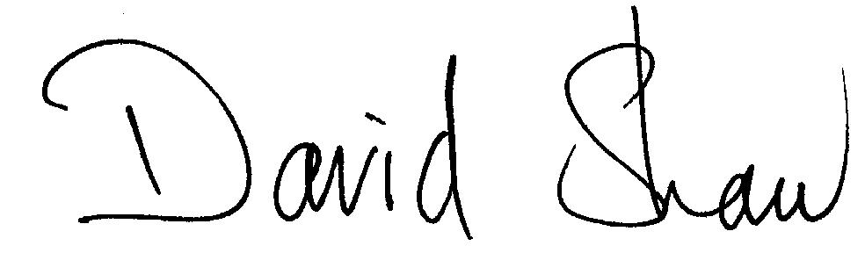

Dr David J. Shaw
Company Secretary
8 October 2007

